
Representing

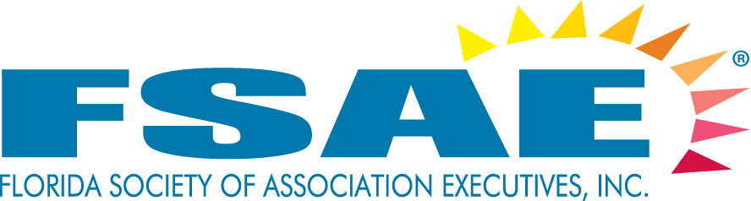

REQUEST FOR PROPOSAL

RESPOND BY SEPTEMBER 30, 2017

DATE: 8/15/2017
TO: All FSAE Associate Member Hotels and CVB’s
FROM: Richard Miseyko, CMP, CMM
RE: FLORIDA SOCIETY OF ASSOCIATION EXECUTIVES – 2018 Events
# OF PAGES: 9

Site Search, Inc. has been asked by the Florida Society of Association Executives (FSAE) to secure locations for its 2018 events. Site Search, Inc. receives no compensation from FSAE or from the host hotels whatsoever for the placement of these events.

A description and the specifications for each of FSAE’s events can be found on the following pages. At the end of this RFP you will find a Response Form for you to select the event(s) you are interested in hosting, along with space to list your available date(s). We ask that you please avoid Holidays and offer as many dates as you can. This will improve the likelihood your property will be selected for at least one meeting.

I would encourage you to partner with your local CVB and local vendors to enhance your bids and to help offset a portion of the hosting costs.

Please Note:
By agreeing to host an event, it is understood that all guest rooms, except where otherwise indicated, meeting space, A/V, Internet (guestrooms and inside assigned meeting space), parking, resort fees, and Food and Beverage as outlined in the specifications will be provided on a complimentary basis.

In order for your property to be considered for selection the host hotel must have an active FSAE member on staff or be willing to have a staff member join FSAE if their site is chosen.

Send your RFP responses via Fax or Email using the attached RFP Response Form by September 30, 2017.

For questions regarding this RFP please contact Richard Miseyko, CMP, CMM, at 727-822-4414 or richard@sitesearchinc.com. Please do NOT contact FSAE with questions.
PROFILE: FSAE is the gateway to doing business with the association market in Florida. With more than 1,050 executive and associate members in the State of Florida, including those who manage trade and professional associations, individual membership societies, charitable organizations and other not-for-profit organizations, FSAE is the recognized public spokesperson and leading resource for information on associations. FSAE represents more than 500 associations whose combined membership exceeds 1.5 million Floridians. These associations also employ 60,000+ Floridians, and spend more than $1.7 billion dollars each year in the state of Florida. Their members host between 5 and 75 meetings each year for their own membership.

2018 FSAE Calendar

2018 Events
Time Frame | Location | Event | Notes
February-April | Central Florida | Power Lunch
April-May | South Florida | Power Lunch/  Associate Advisory Council Meeting
August-December | Central Florida | Power Lunch | *cannot be in October
September-December | South Florida | Power Lunch | *cannot be in October
August-September | Any Florida location | CEO Retreat
November- early December | Central Florida | Power Lunch/  FSAE Board and Foundation Meetings/  Education Committee Meeting

MAP
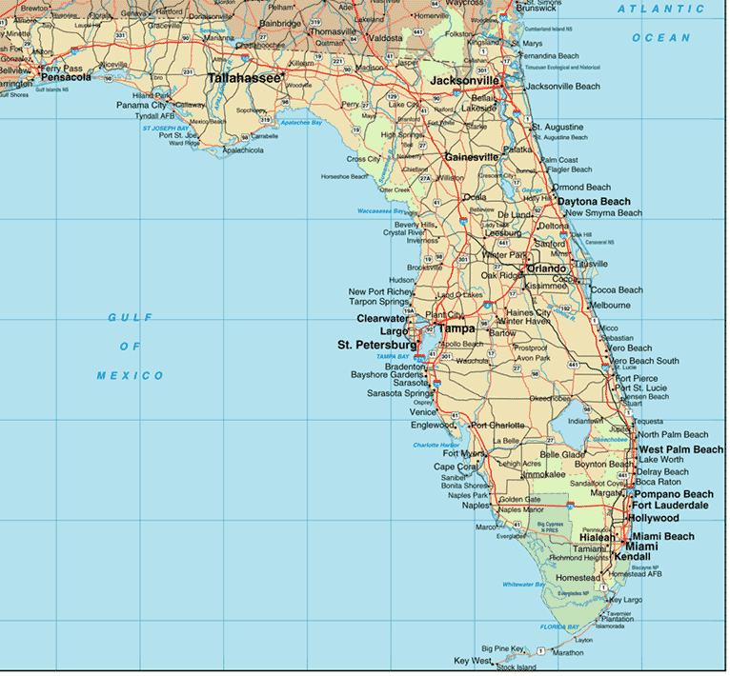
(3) Power Luncheons
1 Day Events
Tuesday, Wednesday or Thursday
(2) Central Florida: February-April and August-December (excluding Oct.),
(1) South Florida: September-December (excluding Oct.)

The purpose of the Power Lunch is to provide a forum for an educational and networking opportunity. Attendance, which usually ranges from 50-75 people, consists of both Executive and Associate members.

Special Notes
By agreeing to host an event, it is understood that all guest rooms, except where otherwise indicated, resort fees, parking, meeting space, A/V, Wi-Fi (guestrooms and inside assigned meeting space), and Food and Beverage as outlined in the specifications will be provided on a complimentary basis.

The host hotel will have an opportunity to welcome the group and will be given recognition on the FSAE Website, in Source magazine, in all FSAE social media and marketing materials related to the sponsored event.

It is highly recommend that an optional tour of the property be conducted after the Power Lunch for those interested in seeing the facility. Participation by the host hotel at the Luncheon (not included in counts below) is welcomed and encouraged.

We ask that properties provide a special pre and post meeting rate for those attendees who would like to arrive before or stay after the scheduled meeting dates.

If a property has a specialty, such as spa or golf, it can be offered at your option for early arrivals or before checkout.

Room Block

 | Evening Prior to Luncheon | Day of Luncheon | Total Room Nights
FSAE Staff/Speaker | 4 | Checkout | 4 Comp
Optional – provide special industry rate for participants of the Power Luncheon
for evening prior to luncheon – historically about 10 rooms.

Tuesday, Wednesday, or Thursday

Function | Time Frame | # of Participants | Setup
Power Luncheon | 11:30 am – 1:00 pm | 50-75pp | RDS
Optional Property Tour | 1:00 pm – 2:00 pm

Power Lunch/ AAC Meeting
April – May
Tuesday, Wednesday, or Thursday
(1 day event)
South Florida Location

Power Lunch
The purpose of the Power Lunch portion of the program is to provide a forum for an educational and networking opportunity. Attendance, which usually ranges from 50-75 people, consists of both Executive and Associate members.

AAC Meeting
The Associate Advisory Committee is comprised of active, engaged associate members that help FSAE meet the needs of our associate members. Attendance is typically around 25-30 members.

Special Notes
By agreeing to host an event, it is understood that all guest rooms, except where otherwise indicated, resort fee, parking, meeting space, A/V, Wi-Fi (guestrooms and inside assigned meeting space), and Food and Beverage as outlined in the specifications will be provided on a complimentary basis.

The host hotel will have an opportunity to welcome the group and will be given recognition on the FSAE Website, in Source magazine, in all FSAE social media and marketing materials.

It is highly recommend that an optional tour of the property be conducted after the Power Lunch for those interested in seeing the facility. Participation by the host hotel at the Luncheon (not included in counts below) is welcomed and encouraged.

We ask that properties provide a special pre- and post-meeting rate for those attendees who would like to arrive before or stay after the scheduled meeting dates.

If a property has a specialty, such as spa and golf, it can be offered at your option for early arrivals or before checkout.

Room Block

 | Evening Prior to Luncheon | Day of Luncheon | Total Room Nights
FSAE Staff | 4 | Checkout | 4 Comp
AAC Committee | 10 | Checkout | 10 nights at a reduced rate (approx. $99/night)
Optional – provide special industry rate for other participants of the Power Luncheon for evening prior to luncheon – historically about 10 rooms.

Day of Event

Function | Time Frame | # of Participants | Setup
AAC Meeting | 8:30 – 11:00 AM OR  1:30 PM – 3:00 PM | 30 pp | HS
Power Lunch | 11:30 AM -1:00 PM | 50-75 pp | Rounds
Optional Property Tour | 1:00 PM – 1:30 PM
CEO Retreat
August-September
(3 day event)
Friday - Sunday
All Florida Locations Will Be Considered

The CEO Retreat provides attendees with an informal and confidential setting to discuss association issues and trends. Attendees are the Association’s key decision makers, the Chief Executive Officer, President or Executive Director. Other than the possibility of one or two speakers, only individuals from an association are invited and allowed to participate. FSAE and Site Search, Inc. screen all applicants for eligibility.

Invited attendees are limited to 25 Executives. Each attendee is allowed to bring one adult spouse/guest (no children allowed). Approximately half the attendees bring a guest. Guests are invited to a reception and dinner on Friday evening and the Saturday morning breakfast, but do not attend the meeting or partake in breaks or lunch Saturday.

Special Notes
By agreeing to host an event, it is understood that all guest rooms, resort fees, parking, meeting space, A/V, Wi-Fi (guestrooms and inside assigned meeting space), and Food and Beverage as outlined in the specifications will be provided on a complimentary basis.

The host hotel will have an opportunity to welcome the group and will be given recognition on the FSAE Website, in Source magazine, in all FSAE social media and marketing materials.

It is highly recommend that a tour of the property be conducted on Friday or Saturday evening. Participation by the host hotel at certain meal functions (not included in counts below) is welcomed and encouraged. Dinners can be done in your hotel restaurants instead of private banquet rooms to avoid additional labor costs allowing the group the opportunity to experience the ambiance of your outlets.

We ask that properties provide a special pre- and post-meeting rate for those attendees who would like to arrive before or stay after the scheduled meeting dates.

If a property has a specialty, such as spa or golf, it can be offered at your option for early arrivals or before checkout.

Room Block

 | Fri | Sat | Sun | Total Room Nights
FSAE Staff/Speaker | 3 | 3 | Checkout | 6 Comp
CEO Retreat Attendees | 25 | 25 | Checkout | 50 comp

Friday

Function | Time Frame | # of Participants | Setup
Welcome Reception (optional) | 6:30 pm – 7:30 pm | 30-40pp
Dinner (optional) | 8:00 pm – 9:00 pm | 30-40pp | RDS

Saturday

Function | Time Frame | # of Participants | Setup
Breakfast Buffet | 8:00 am – 9:00 am | 30-40pp | RDS
Meeting | 9:00 am – 5:00 pm | 27pp | U Shape
Lunch | 12:00 pm – 1:00 pm | 27pp | RDS
Refreshment Break | 2:15 pm | 27pp
Reception | 6:30 pm – 7:30 pm | 30-40pp
Property Tour (suggested/optional) | 7:30 pm – 8:00 pm | 30-40pp
Dinner | 7:30/8:00 pm – 9:00 pm | 30-40pp | RDS

Power Lunch/FSAE and Foundation Board Meetings/
Education Committee Meeting
November – early December
(3 day event)
Wednesday-Friday
Central Florida Location

Power Lunch
The purpose of the Power Lunch portion of the program is to provide a forum for an educational and networking opportunity. Attendance, which usually ranges from 50-75 people, consists of both Executive and Associate members.

FSAE and Foundation Board Meetings
The FSAE Board of Directors and FSAE Foundation Board of Trustees are charged with building highly effective organizations. They are led by skilled leaders who maintain fiscal stability and viability. Their combined focus is the success for our members and our profession through professional development, research, education, publications and public relations efforts for the association management profession.

The Boards are comprised of 25 individuals. Each FSAE/Foundation Board Member is allowed to bring one spouse/guest (approximately half the board attendees bring a guest, and no children are allowed). Guests are invited to attend the Wednesday Reception and Dinner.

Education Committee Meeting
The FSAE Education Committee will have a face-to-face meeting on the final day of this meeting. They will be evaluating speaker submissions for selection to present at the FSAE Annual Conference, the Education Expo, and future Power Luncheons. There are approximately 15 committee members.

Special Notes
By agreeing to host an event, it is understood that all guest rooms, except where otherwise indicated, resort fee, parking, meeting space, A/V, Wi-Fi (guestrooms and inside meeting rooms), and Food and Beverage as outlined in the specifications will be provided on a complimentary basis.

The host hotel will have an opportunity to welcome the group and will be given recognition on the FSAE Website, in Source magazine, in all FSAE social media and marketing materials.

It is highly recommend that a tour of the property be conducted on Wednesday evening. Participation by the host hotel at certain meal functions (not included in counts below) is welcomed and encouraged. Dinners can be done in your hotel restaurants instead of private banquet rooms to avoid additional labor costs allowing the group the opportunity to experience the ambiance of your outlets.

We ask that properties provide a special pre- and post-meeting rate for those attendees who would like to arrive before or stay after the scheduled meeting dates, and for Education Committee members who are attending the Friday morning meeting.

If a property has a specialty, such as spa and golf, it can be offered at your option for early arrivals or before checkout.

Room Block

 | Wed | Thu | Fri | Total Room Nights
FSAE Staff | 4 | 4 | Checkout | 8 Comp
FSAE and FDN Board Members | 25 | 12 | Checkout | 37 Comp
Optional – provide special industry rate for participants of the Power Luncheon for evening prior to luncheon – historically about 10 rooms.

Wednesday

Function | Time Frame | # of Participants | Setup
Welcome Reception | 6:30 pm – 7:30 pm | 55 pp | Reception
Hotel Site Tour | 7:30 pm – 8:00 pm | 55 pp | Tour
Dinner | 8:00 pm – 10:00 pm | 55 pp | RDS

Thursday

Function | Time Frame | # of Participants | Setup
Board Meeting | 8:30 am – 11:30 am | 36 pp | HS
Power Luncheon | 11:30 am – 1:30 pm | 55-75pp | RDS
Board Meeting | 2:00 pm – 5:00 pm | 36pp | HS
Refreshment Break | 2:30 pm | 36pp

Friday

Function | Time Frame | # of Participants | Setup
Buffet Breakfast (optional) | 8:00 am – 9:00 am | 20 pp | RDS
Education Committee Meeting | 9:00 am – 12:00 pm | 20 pp | HS
Refreshment Break (optional) | 10:30 am | 20 pp
Lunch (optional) | 12:00 pm – 1:00 pm | 20 pp | RDS

Previous FSAE/FSAE Foundation Meeting Hosts

Previous host of FSAE and FSAE Foundation events can attest to the value of the investment
of bringing these groups to their properties. For your reference you will find below a brief list of some
of the properties that have hosted one of the FSAE or FSAE Foundation events.

Boca Raton Resort & Club
Busch Gardens Tampa Bay
Caribe Royale Orlando
Casa Marina
Disney’s Boardwalk
Doubletree Orlando Resort
El Conquistador (Puerto Rico)
Embassy Suites by Hilton Lake Buena Vista South
Hammock Beach Resort
Hilton Orlando
Hilton Orlando / Altamonte Springs
Hilton SanDestin Beach Golf Resort & Spa
Hyatt Regency Bonaventure
Hyatt Regency Coconut Point
Hyatt Regency Sarasota
Innisbrook Resort
Lowes Don CeSar
Lowes South Beach
Marco Island Marriott
Marriott Bay Point
Mission Inn
Naples Beach Hotel & Golf Club
Omni Champions Gate
Pelican Grand Beach Resort
PGA National Resort & Spa
Plantation Inn
Plaza Resort Daytona
Registry Resort
Renaissance Orlando at Sea World
Renaissance Plantation
Renaissance Vinoy Resort
Riverside Hotel
Rosen Centre Hotel
Royal Caribbean Cruise Lines
SanDestin Resort
Safety Harbor Resort & Spa
Seminole Hard Rock Tampa
Sheraton Suites Fort Lauderdale at Cypress Creek
Sirata Beach Resort
South Seas Island Resort
The Breakers, Palm Beach
The Grove Resort & Spa
The Peabody Orlando
The Villas of Grand Cypress
Trade Winds Island Grand
Watercolor Resort
Westin Fort Lauderdale Beach Resort
Westin Imagine Hotel
Wyndham Grand Jupiter at Harbourside Place
Wyndham Orlando Resort International Drive

FAX TO: Richard Miseyko, Site Search, Inc. 727-822-8702 or
EMAIL: richard@sitesearchinc.com RE: Florida Society of Association Executives – 2018 Events

RFP Response Form

Hotel Name:
Sales Contact: |  | Title:
Email: |  | Phone:

By placing available dates in the right hand column you are confirming availability for that date and agree to provide all the guest rooms, except where otherwise indicated in the RFP, resort fee, parking, meeting space, A/V, Wi-fi (guestrooms and inside assigned meeting space) and Food and Beverage as outlined in the specifications for that particular meeting on a complimentary basis. Bidding on more than one event increases the likelihood your property will be selected.

2018 Events
Time Frame | Location | Event | Dates
Feb-April | Central Florida | Power Lunch
April- May | South Florida | Power Lunch/  Associate Advisory Council Meeting
August-December  *cannot be in October | Central Florida | Power Lunch
September–December  *cannot be in October | South Florida | Power Lunch
August - September | Any Florida location | CEO Retreat
November- early December | Central Florida | Power Lunch/  FSAE Board and Foundation Meetings/  Education Committee Meeting

Extras:
Would you like to offer any additional services on a comp basis (spa, golf, spouse/guest tours)?
Tell us about your recent renovations awards, and reasons to consider your property.
If you’re bidding on an event that requests an industry rate for those not covered by the comp roomnights, or a rate for pre/post stays, please indicate the rate.

